Chapter 2:

**Literature/Market Survey**

# Chapter: 2

# Literature/Market Survey

This chapter aims to provide an overview of the current state of autonomous vehicles, including existing developments and ongoing testing. It will explore the origins of autonomous vehicles and the regulatory bodies responsible for establishing rules. Furthermore, it will identify prominent market participants involved in advancing autonomous vehicle technologies.

## Introduction

The concept of autonomous vehicles is not fresh in the automotive industry. Companies such as Tesla, General Motors, BMW, Mercedes, Honda, KIA, Toyota, among others, have been actively involved in this field. While many have developed vehicles equipped with level 2 and level 3 autonomous systems, not all have released them to the market. The Society of Automotive Engineers (SAE) has established six levels of driving automation, ranging from level 0 (fully manual) to level 5 (fully autonomous).

## Literature Review / Technology Overview

The concept of autonomous vehicles traces back to 1918, with early attempts in the 1920s. General Motors was among the pioneers, showcasing autonomous vehicle concepts at exhibitions. The research and development efforts for autonomous vehicles gained momentum with initiatives like General Motors and Radio Corporation of America Sarnoff Laboratory's collaboration. Notably, the Defense Advanced Research Projects Agency (DARPA) Grand Challenges Program in 2004 accelerated autonomous vehicle research in the US.

Today, the global autonomous vehicle market boasts key players including AB Volvo, BMW AG, Daimler AG, Ford Motor Company, General Motors, Honda Motor Co., Ltd., Nissan Motors Co., Ltd., Tesla, Inc., Toyota Motor Corporation, and Volkswagen AG.

* **AB Volvo**: Began autonomous vehicle development in 2006 and unveiled a fully autonomous test vehicle in 2017, though commercially available self-driving cars from Volvo are still pending.
* **Waymo** (Google's subsidiary): Made significant progress, logging millions of autonomous driving miles. Currently offers limited commercial self-driving ride-hailing services in specific locations.
* **Tesla**: Announced plans for self-driving features in their cars in 2014, promoting them as standard. Notably, Tesla's Autopilot is a driver-assistance system rather than fully autonomous, and has faced safety criticisms.

AVs operate themselves and execute necessary functions without human intervention. This is achieved through their ability to sense their surroundings using advanced technologies such as artificial intelligence (AI) software, light detection and ranging (LiDAR), radio detection and ranging (RADAR), and cameras. These sensors enable the vehicle to form an active 3D map of its environment, allowing it to navigate safely and efficiently.

* + 1. **Levels of Autonomous Vehicles**

Understanding the different levels of autonomy set by the Society of Automotive Engineers (SAE) International is crucial before discussing existing autonomous vehicle systems. These levels explain how much control the vehicle has versus the human. The table below shows these levels, from full human control to full automation, making it easier to understand the capabilities of existing systems.

|  |  |
| --- | --- |
| **Levels of Taxonomy** | **Description** |
| **Level 0**  No automation | Zero autonomy; the driver performs all driving tasks. |
| **Level 1**  Driver assistance | The vehicle is controlled by the driver but driving assist features may be included in the vehicle design. |
| **Level 2**  Partial automation | Vehicles have combined automated functions, like acceleration and steering, but the driver must remain engaged with the driving task and always monitor the environment. |
| **Level 3**  Conditional automation | A driver is a necessity but is not required to monitor the environment. The driver must be ready to always take control of the vehicle with notice. |
| **Level 4**  High automation | The vehicle can perform all driving functions under certain conditions. The driver may have the option to control the vehicle. |
| **Level 5**  Full automation | The vehicle can perform all driving functions under all conditions. |

*Table 2.1 - Levels of taxonomy*

* 1. 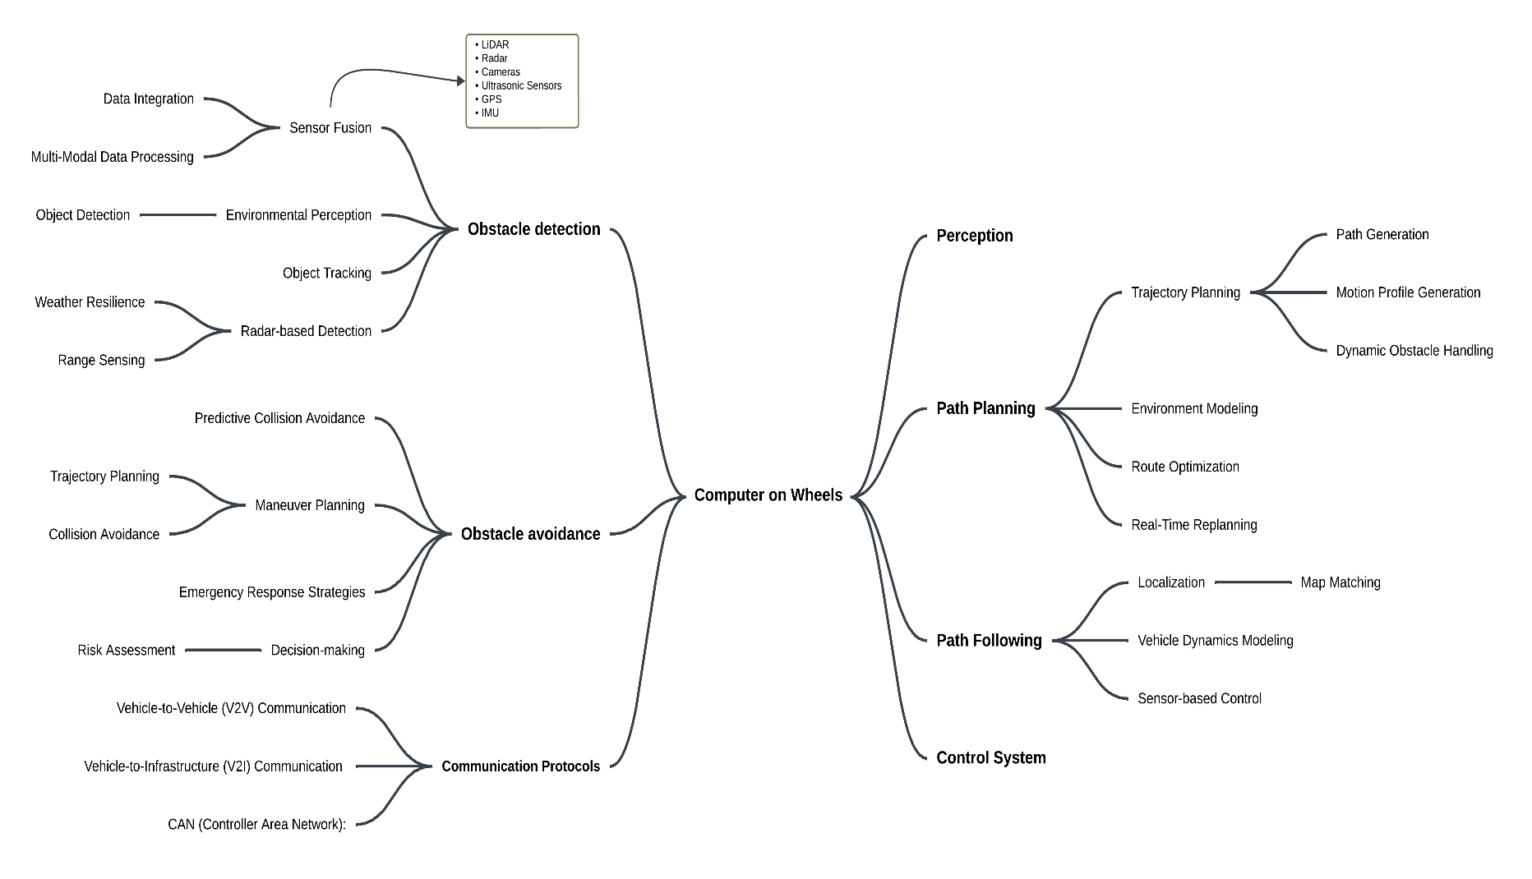**Brainstorming**
  2. **Existing Systems**

|  |  |  |
| --- | --- | --- |
| **Company** | **Target Level** | **Key Features** |
| **Tesla, Ford, Toyota** | Level 2 (Autopilot) | * Lane keeping * automatic emergency braking * traffic light and stop sign recognition * highway driving assist * self-parking (Level 2) * Navigate on Autopilot |
| **BMW, Nissan** | Level 2 | * Adaptive cruise control with stop-and-go * lane departure warning * lane change assist |

*Table 2.4.1* **|** *Existing Systems*

|  |  |  |
| --- | --- | --- |
| **Honda, Mercedes-Benz** | Level 3 (conditional) | * Hands-free driving at up to 60 km/h on specific highways * automatic lane changes * traffic jam assist * emergency stop assists |
| **Way-mo** | Level 4 | * LiDAR-based system for navigating complex * extensive real-world testing * millions of miles driven |
| **Cruise** | Level 5 | Fully autonomous robo-taxi |

*Table 2.4.2* **|** *Existing Systems*

Currently, the automotive market provides vehicles with Levels 0, 1, and 2 of automation. Levels 3, 4, and 5 are still in the **testing phase** and not widely available for commercial use.

## Summary

This chapter analyzes the current landscape of autonomous vehicles (AVs). While various companies are actively developing AV technology, commercially available vehicles primarily offer Levels 0 (no automation), 1 (driver assistance features), and 2 (partial automation) of driving autonomy as defined by the Society of Automotive Engineers (SAE). Levels 3 (conditional automation), 4 (high automation), and 5 (full automation) remain under development and testing.